PEDIATRIC ADVANCED LIFE SUPPORT

REFERENCE GUIDE

JOE JONES, NREMT-PARAMEDIC

BLS Considerations During PALS
High quality CPR is a must in the attempts in successful resuscitation of a Pediatric patient suffering from cardiopulmonary arrest. One should always attempt to identify the cause and treat it accordingly.
ESTABLISH UNRESPONSIVENESS
CHILD PULSELESS AND APNEIC
BEGIN CPR WITH QUALITY CHEST COMPRESSIONS (rate at least 100/minute)
( one rescuer begins chest compressions while second prepares to ventilate)
( other rescuers now should be retrieving the monitor/AED)
( compress at least 1and ½ inches on an infant and 2 inches on the pediatric)
ONCE THE DEFIFTILLATOR ARRIVES THEN ATTACH TO PATIENT, STOP COMPRESSIONS AND IDENIFY THE RHYTHM OR FOLLOW THE PROMPTS ON THE AED…..
FROM THIS POINT TREAT ACCORDING TO THE PROPER ALOGORHYTHM RECOMMENDED BY THE AMERICAN HEART ASSOCIATION.

ALWAYS MAKE SURE PATIENT IS ON A FIRM SURFACE WHILE PERFORMING CPR AND WHEN ENOUGH PERSONEL ARE PRESENT SWITCH COMPRESSORS EVERY 2 MINUTES TO PREVENT TIRING WHICH WOULD LEAD TO POOR COMPRESSIONS.

COMMON CAUSES OF ARREST IN THE PED PT.
In contrast to adults, cardiac arrest in infants and children does not usually result from a primary cardiac cause. More often it is the terminal result of progressive respiratory failure or shock, also called an asphyxial arrest. Asphyxia begins with a variable period of systemic hypoxemia, hypercapnea, and acidosis, progresses to bradycardia and hypotension, and culminates with cardiac arrest.¹
Another mechanism of cardiac arrest, ventricular fibrillation (VF) or pulseless ventricular tachycardia (VT), is the initial cardiac rhythm in approximately 5% to 15% of pediatric in-hospital and out-of-hospital cardiac arrests it is reported in up to 27% of pediatric in-hospital arrests at some point during the resuscitation. The incidence of VF/pulseless VT cardiac arrest rises with age. Increasing evidence suggests that sudden unexpected death in young people can be associated with genetic abnormalities in myocyte ion channels resulting in abnormalities in ion flow
Hypoxemia is a common cause of cardiopulmonary arrest in the pediatric patient. Treat respiratory problems aggressively in order to prevent respiratory distress or failure will lead to respiratory arrest rapidly.
If a child in intubated monitor them closely for any problems with ventilator or the endotracheal tube, these can cause detrimental problems for the patient.
Perform a good physical exam on any child with respiratory complaints. Always obtain a good history and physical exam.
Pneumonia, Bronchitis and Asthma is common in the child. Treatment for these would be to:
Maintain A – B – C’s
Monitor oxygen saturation
Administer Oxygen
Wheezing Present then:
Beta Agonist Medications
Consider Steroids
Chest X-Ray
Consider asthma attacks which can not be broken with Beta Agonist Medications alone a life threatening problem.
Keep in mind Subcutaneous Epinephrine .01 mg/kg
Monitor heart rhythm, hypoxemia will lead to bradycardia which will lead to cardiopulmonary arrest.
Correct problems such as these early to prevent child from deteriorating.
SHOCK
Shock
Shock results from inadequate blood flow and oxygen delivery to meet tissue metabolic demands. The most common type of shock in children is hypovolemic, including shock due to hemorrhage. Distributive, cardiogenic, and obstructive shock occur less frequently. Shock progresses over a continuum of severity, from a compensated to a decompensated state. Compensatory mechanisms include tachycardia and increased systemic vascular resistance (vasoconstriction) in an effort to maintain cardiac output and perfusion pressure respectively. Decompensation occurs when compensatory mechanisms fail and results in hypotensive shock.
Typical signs of compensated shock include
- Tachycardia
- Cool and pale distal extremities
- Prolonged (>2 seconds) capillary refill (despite warm ambient temperature)
- Weak peripheral pulses compared with central pulses
- Normal systolic blood pressure
As compensatory mechanisms fail, signs of inadequate end-organ perfusion develop. In addition to the above, these signs include
- Depressed mental status
- Decreased urine output
- Metabolic acidosis
- Tachypnea
- Weak central pulses
- Deterioration in color (eg, mottling, see below)
Decompensated shock is characterized by signs and symptoms consistent with inadequate delivery of oxygen to tissues (pallor, peripheral cyanosis, tachypnea, mottling of the skin, decreased urine output, metabolic acidosis, depressed mental status), weak or absent peripheral pulses, weak central pulses, and hypotension.
Learn to integrate the signs of shock because no single sign confirms the diagnosis. For example:
- Capillary refill time alone is not a good indicator of circulatory volume, but a capillary refill time >2 seconds is a useful indicator of moderate dehydration when combined with decreased urine output, absent tears, dry mucous membranes, and a generally ill appearance. Capillary refill time is influenced by ambient temperature,²⁵ site, and age and its interpretation can be influenced by lighting.²⁶
- Tachycardia is a common sign of shock, but it can also result from other causes, such as pain, anxiety, and fever.
- Pulses are weak in hypovolemic and cardiogenic shock, but may be bounding in anaphylactic, neurogenic, and septic shock.
- Blood pressure may be normal in a child with compensated shock but may decline rapidly when the child decompensates. Like the other signs, hypotension must be interpreted within the context of the entire clinical picture.
There are several sources of data that use large populations to identify the 5th percentile for systolic blood pressure at various ages.^{27,28} For purposes of these guidelines, hypotension is defined as a systolic blood pressure:
- <60 mm Hg in term neonates (0 to 28 days)
- <70 mm Hg in infants (1 month to 12 months)
- <70 mm Hg + (2 x age in years) in children 1 to 10 years
- <90 mm Hg in children 10 years of age

Treatment for Shock would include:
Maintain A –B – C’s
Oxygen high flow
Cardiac Monitor
Monitor saturation levels
Hypovolemia non-hemorrhagic: IV isotonic solution at 20 ml/kg may repeat up to 4 times if needed. Make sure to reassess after each bolus of fluid.
Hypovolemia due hemorrhage: IV isotonic solution at 20 ml/kg initially then consider 10 ml/kg of packed red blood cells or 20 ml/kg of whole blood. In certain cases one may consider hypertonic solutions, i.e. Hextend.
Anaphylaxis is a highly deadly, be aggressive with airway treatment, Epinephrine 0.01 mg/kg of a 1 – 1000 solution subcutaneous or I.M. or if hypotension is present then 0.01 mg/kg of a 1 – 10,000 solution IVP, Benadryl 1 – 2 mg/kg, consider steroids. Hypotension present then 20 ml/kg of a isotonic solution bolus then reassess, consider use of vasoactive drugs such a dopamine in severe cases at 2 – 20 mcg/kg/min.
Neurogenic Shock protect the C-Spine and administer IV isotonic solutions at 20 ml/kg consider IV steroids.
Cardiogenic shock Access lung sounds prior to fluid. Remember these children can fill up fast when the pump is not pumping well. Consider vasoacive medications such as Dopamine, Dobutrex, or even possibly Levophed. Remember to seek expert consultation.
Septic Shock: IV isotonic solution at 20 ml/kg may repeat then consider the use of vasopressors such as dopamine. Work to finding out what’s causing the infection and treat it aggressively.
After dopamine has been used and not effective then a patient who is experiencing cold shock use epinephrine and the patient with warm shock use levophed.

CARDIAC ARRHYTHMIAS

The primary cause of bradycardia in the pediatric patient comes from hypoxemia. One must be aggressive with the airway and breathing and maintain good oxygen saturation. In certain cases the pediatric patient will experience a vagal maneuver which will cause bradycardia to occur. Treatment should include the following.
A – B – C’s be sure to provide high concentrations of oxygen. In cases where breathing is inadequate be aggressive with ventilators. If unsuccessful then:
Monitor/EKG observe closely
IV isotonic solution at a to keep open rate do not overload the patient remember the pump is not pumping.
Epinephrine IVP 1 – 10,000 solution 0.01 mg/kg
Continue to monitor the patient and assure that airway and ventilation is being carried out correctly.
Repeat Epinephrine IVP 1 – 10,000 solution 0.01 mg/kg and repeat q-3 – 5 minutes
Seek Expert consultation if not already done so, also consider chronotropic meds such as dopamine at 2 – 10 mcg/kg/min.
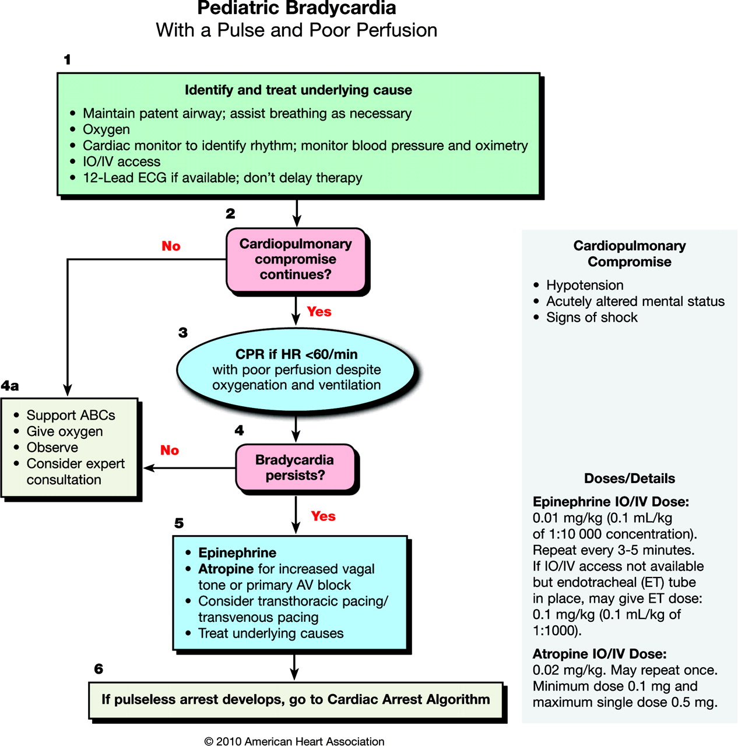

With tachycardia one must assess for all causes before beginning treatment. Assure this is a cardiac problem rather than something which can be corrected with a more simple approach. Remember the response to pain, fever, Hypovolemia are causes of tachycardia, rule out these causes first. A child is not considered to be in Supraventricular Tachycardia until the rate is greater than 180 and the infant must be greater than 220. Always assess the patient and determine if he/she is unstable or stable.
STABLE SVT (NARROW COMPLEX)
A – B- C’s provide high concentration of oxygen
EKG monitor closely
Seek Expert consultation
Vagal Manuvers: blow into a closed straw, ice water to the face etc. Do not attempt to massage eyelids due to this may cause retina problems. If unsuccessful then move to more aggressive rx.
IV at kvo rate remember do not overload the patient.
Adenosine 0.1 mg/kg do not exceed 6 mg. repeat in 2 – 3 minutes
Adenosine 0.2 mg/kg do not exceed 12 mg. repeat in 2 – 3 minutes
Adenosine 0.2 mg/kg do not exceed 12 mg. max dose given
If Adenosine is unsuccessful then go to synchronized cardioversion if time permits sedation is recommended.
Start at .5 – 1 joule per kg may repeat at 2 joules per kg
Consider amiodarone 5 mg/kg IO/IV or procainamide 15 mg/kg IO/IV for a patient with SVT unresponsive to vagal maneuvers and adenosine and/or electric cardioversion; for hemodynamically stable patients, expert consultation is strongly recommended prior to administration. Both amiodarone and procainamide must be infused slowly (amiodarone over 20 to 60 minutes and procainamide over 30 to 60 minutes), depending on the urgency, while the ECG and blood pressure are monitored. If there is no effect and there are no signs of toxicity, give additional doses avoid the simultaneous use of amiodarone and procainamide without expert consultation.

WIDE COMPLEX
SEEK EXPERT CONSULTATION IMMEDIATELY

- Adenosine 0.1 mg/kg do not exceed 6 mg.
- Adenosine 0.2 mg/kg do not exceed 12 mg
- Cordarone 5 mg/kg, may repeat x 1 dose
- Cordarone not available Lidocaine .5 – 1 mg/kg
- Consider Procainamide if Lidocaine not successful however if Cordarone has been administered then do not give Pronestyl
- Consider synchronized Cardioversion

UNSTABLE TACHYCARDIA
- Evaluate the rhythm, wide complex vs. narrow complex
- Identify and treat the underlying cause of the tachycardia, (Sinus Tachycardia, hypovolemia, fever, pain, shortness of breath, etc.
- Supraventricular/Ventricular Tachcardia
- Serious Signs and Symptoms present: Decrease LOC, Hypotension etc.
- Prepare for immediate cardioversion
- A – B – C’s
- Apply Oxygen
- Time Permitting 12 Lead EKG
- IV/IO NaCl at kvo rate
- Consider Sedation
- Synchronize Cardiovert at .5 – 1 joule/kg
- Serious Signs Still Present
- Synchronize Cardiovert at 2 joules/kg.
- 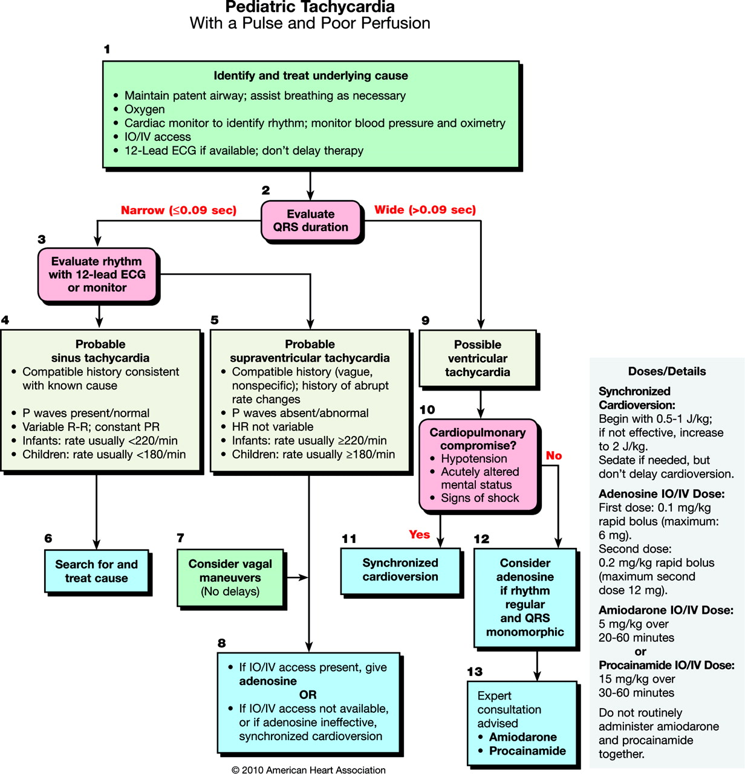

ASYSTOLE/PEA
- As soon as the child has been identified as being in arrest then begin compressions immediately.
- Call for monitor/AED and as soon as it arrives attach to the patient stop CPR and check rhythm.
- CONFIRM RHYTHM – ASYSTOLE/PEA PRESENT THEN:
- Continue CPR while 2nd rescuer establishes IV
- Administer Epinephrine 0.01 mg/kg and repeat every 3 – 5 minutes. High dose Epinephrine has not showed any benefit other than a Beta Blocker overdose…
- Intubate the patient and confirm placement of tube. BBS/Rise and fall of the chest/End tital CO2 detector/Waveform Capnography.
- Once intubation has been achieved then continue CPR without interruptions at a rate of at least 100/minute and ventilations at 8 – 10 times per minute
- Continue the administration of Epinephrine
- Attempt to figure out the reason for arrest and treat accordingly.
- Hypovolemia administer fluids at 20 ml/kg, Drug overdose, attempt to reverse the drug responsible for the arrest, Tension Pneumothorax decompress at the second intercostal space above the third rib, Metabolic Acidosis treat with Bicarbonate at 1 – MEQ/kg. Cardiac Tamponade perform pericardiocentesis

VENTRICULAR FIBRILLATION
PULSELESS VENTRICULAR TACHYCARDIA
- Call for help activate the emergency response team.
- Assess unresponsiveness
- Child Pulseless and Apneic
- Begin Chest Compressions at least 100 times per-minute
- Call for AED or Defibrillator
- Continue chest compressions until Defibrillator is connected
- Stop compressions (rhythm above)
- Defibrillate at 2 joules/kg
- Continue CPR
- Initiate IV/IO
- Defibrillate at 4 joules/kg (not to exceed 10 mg/kg or adult dose)
- Administer Epinephrine 0.01 mg/kg
- Continue CPR for 2 minutes then
- Defibrillate
- Continue CPR
- Administer Cordarone 5 mg/kg (repeat x1 dose)
- Cordarone not available then Administer Lidocaine 0.5 – 1 mg/kg (max 3 mg/kg)
- Advanced Airway in place
- Once airway is in place one rescuer should give continuous chest compressions while the other rescuer delivers ventilations at a rate of 1 breath every 6 to 8 seconds or about 8 to 10 per minute.

PALS Pulseless Arrest Algorithm
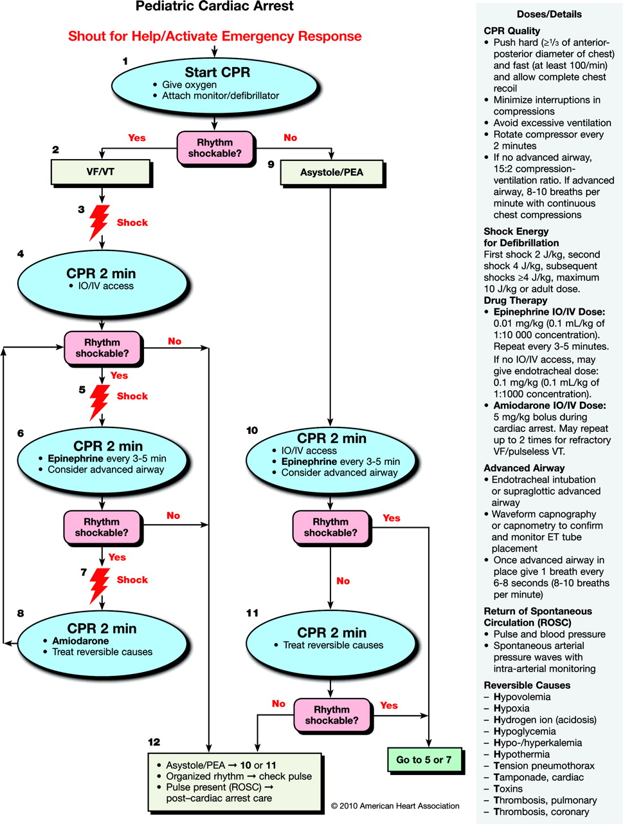
Copyright ©2010 American Heart Association
Kleinman, M. E. et al. Circulation 2010;122:S876-S908
Medications
Adenosine
Adenosine causes a temporary atrioventricular (AV) nodal conduction block and interrupts reentry circuits that involve the AV node. The drug has a wide safety margin because of its short half-life. Adenosine should be given only IV or IO, followed by a rapid saline flush to promote drug delivery to the central circulation. If adenosine is given IV, it should be administered as close to the heart as possible. (See also "Arrhythmia.")
Amiodarone
Amiodarone slows AV conduction, prolongs the AV refractory period and QT interval, and slows ventricular conduction (widens the QRS). Expert consultation is strongly recommended prior to administration of amiodarone to a pediatric patient with a perfusing rhythm. (See also "Arrhythmia.")
Precautions
Monitor blood pressure and electrocardiograph (ECG) during intravenous administration of amiodarone. If the patient has a perfusing rhythm, administer the drug as slowly (over 20 to 60 minutes) as the patient's clinical condition allows; if the patient is in VF/pulseless VT, give the drug as a rapid bolus. Amiodarone causes hypotension through its vasodilatory property, and the severity is related to the infusion rate; hypotension is less common with the aqueous form of amiodarone.²⁰⁷ Decrease the infusion rate if there is prolongation of the QT interval or heart block; stop the infusion if the QRS widens to >50% of baseline or hypotension develops. Other potential complications of amiodarone include bradycardia and torsades de pointes ventricular tachycardia. Amiodarone should not be administered together with another drug that causes QT prolongation, such as procainamide, without expert consultation.
Atropine
Atropine sulfate is a parasympatholytic drug that accelerates sinus or atrial pacemakers and increases the speed of AV conduction.
Precautions
Small doses of atropine (<0.1 mg) may produce paradoxical bradycardia because of its central effect.²⁰⁸ Larger than recommended doses may be required in special circumstances such as organophosphate poisoning²⁰⁹ or exposure to nerve gas agents.

Calcium
Calcium administration is not recommended for pediatric cardiopulmonary arrest in the absence of documented hypocalcemia, calcium channel blocker overdose, hypermagnesemia, or hyperkalemia (Class III, LOE B). Routine calcium administration in cardiac arrest provides no benefit^{210–221} and may be harmful.^{210–212}
If calcium administration is indicated during cardiac arrest, either calcium chloride or calcium gluconate may be considered. Hepatic dysfunction does not appear to alter the ability of calcium gluconate to raise serum calcium levels.²²² In critically ill children, calcium chloride may be preferred because it results in a greater increase in ionized calcium during the treatment of hypocalcemia.^{222A} In the nonarrest setting, if the only venous access is peripheral, calcium gluconate is recommended because it has a lower osmolality than calcium chloride and is therefore less irritating to the vein.
Epinephrine
The -adrenergic-mediated vasoconstriction of epinephrine increases aortic diastolic pressure and thus coronary perfusion pressure, a critical determinant of successful resuscitation from cardiac arrest.^{223,224} At low doses, the β-adrenergic effects may predominate, leading to decreased systemic vascular resistance; in the doses used during cardiac arrest, the vasoconstrictive -effects predominate.
Precautions
- Do not administer catecholamines and sodium bicarbonate simultaneously through an IV catheter or tubing because alkaline solutions such as the bicarbonate inactivate the catecholamines.
- In patients with a perfusing rhythm, epinephrine causes tachycardia; it may also cause ventricular ectopy, tachyarrhythmias, vasoconstriction, and hypertension.
Glucose
Because infants have a relatively high glucose requirement and low glycogen stores, they may develop hypoglycemia when energy requirements rise.²²⁵ Check blood glucose concentration during the resuscitation and treat hypoglycemia promptly (Class I, LOE C).²²⁶
Lidocaine
Lidocaine decreases automaticity and suppresses ventricular arrhythmias,²²⁷ but is not as effective as amiodarone for improving ROSC or survival to hospital admission among adult patients with VF refractory to shocks and epinephrine.²²⁸ Neither lidocaine nor amiodarone has been shown to improve survival to hospital discharge.
Precautions
Lidocaine toxicity includes myocardial and circulatory depression, drowsiness, disorientation, muscle twitching, and seizures, especially in patients with poor cardiac output and hepatic or renal failure.^{229,230}

Magnesium
Magnesium is indicated for the treatment of documented hypomagnesemia or for torsades de pointes (polymorphic VT associated with long QT interval). There is insufficient evidence to recommend for or against the routine administration of magnesium during cardiac arrest.^{231–233}
Precautions
Magnesium produces vasodilation and may cause hypotension if administered rapidly.
Procainamide
Procainamide prolongs the refractory period of the atria and ventricles and depresses conduction velocity.
Precautions
There is limited clinical data on using procainamide in infants and children.^{234–236} Infuse procainamide very slowly (over 30 to 60 minutes) while monitoring the ECG and blood pressure. Decrease the infusion rate if there is prolongation of the QT interval, or heart block; stop the infusion if the QRS widens to >50% of baseline or hypotension develops. Do not administer together with another drug causing QT prolongation, such as amiodarone, without expert consultation. Prior to using procainamide for a hemodynamically stable patient, expert consultation is strongly recommended.
Sodium Bicarbonate
Routine administration of sodium bicarbonate is not recommended in cardiac arrest (Class III, LOE B).^{212,237,238} Sodium bicarbonate may be administered for treatment of some toxidromes (see "Toxicological Emergencies," below) or special resuscitation situations such as hyperkalemic cardiac arrest.
Precautions
During cardiac arrest or severe shock, arterial blood gas analysis may not accurately reflect tissue and venous acidosis.^{239,240} Excessive sodium bicarbonate may impair tissue oxygen delivery;²⁴¹ cause hypokalemia, hypocalcemia, hypernatremia, and hyperosmolality;^{242,243} decrease the VF threshold;²⁴⁴ and impair cardiac function.
Vasopressin
There is insufficient evidence to make a recommendation for or against the routine use of vasopressin during cardiac arrest. Pediatric^{245–247} and adult^{248,249} case series/reports suggested that vasopressin²⁴⁵ or its long-acting analog, terlipressin,^{246,247} may be effective in refractory cardiac arrest when standard therapy fails. A large pediatric NRCPR case series, however, suggested that vasopressin is associated with lower ROSC, and a trend toward lower 24-hour and discharge survival.²⁵⁰ A preponderance of controlled trials in adults do not demonstrate a benefit.^{251–256}

